**AWS SQS , Amazon MQ**

**Example Task SQS: create a queue and send a message.**

Step 1: Create a Queue  
1. Go to AWS Console → SQS → Create Queue.  
2. Select Standard Queue (FIFO queues behave slightly differently).  
3. Give it a name: demo-queue.  
4. Keep default settings (Visibility Timeout = 30 seconds).  
5. Click Create Queue.

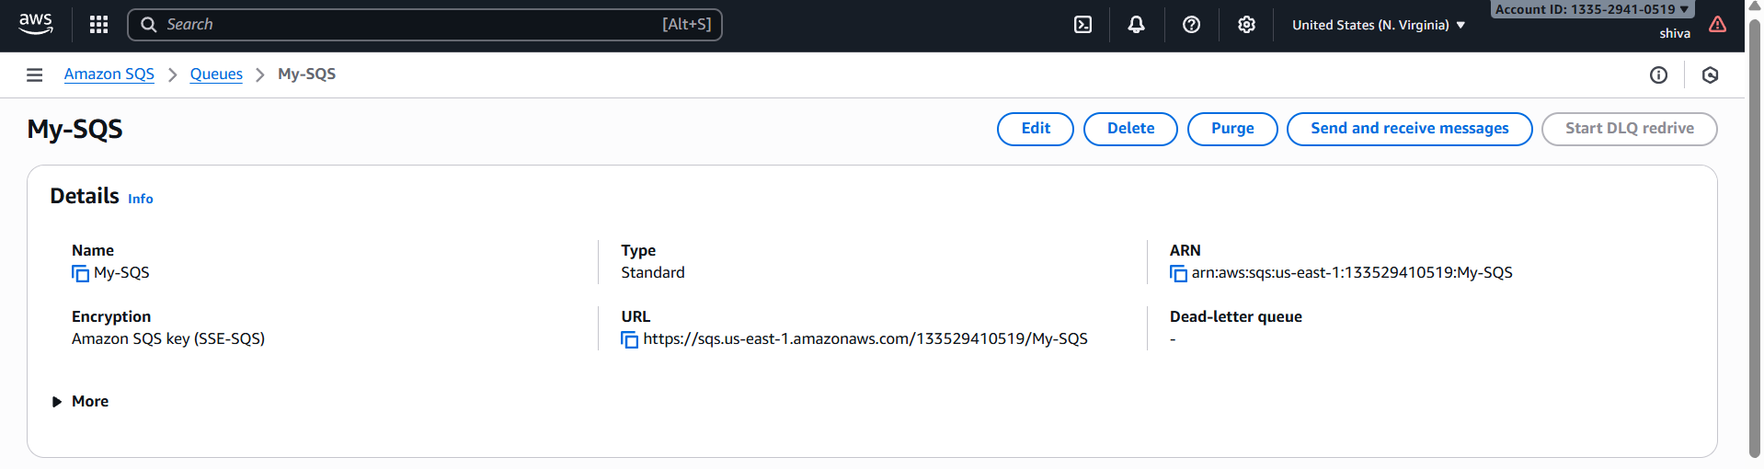

Step 2: Send a Message

1. Open your queue → Click Send and receive messages.  
2. In the “Message body” type something like:  
Hello, this is my first message!

Hello this second message

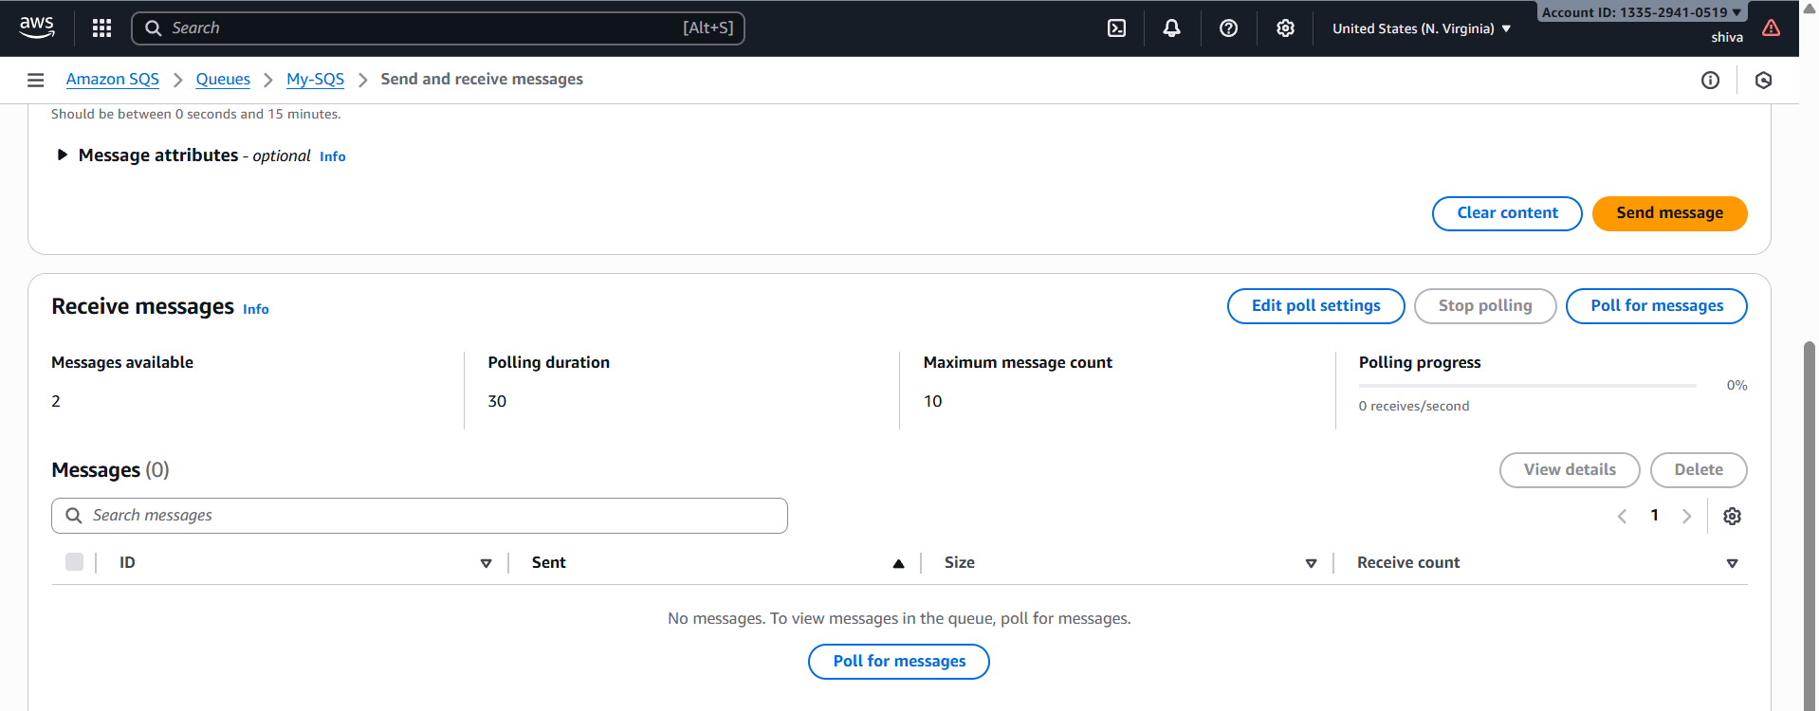

Step 3: Poll for Messages

1. In the same screen → Click Poll for messages.  
2. You’ll see your message appear in the message list.  
👉 At this point, the message is NOT deleted. It just became invisible for the Visibility Timeout   
(30s default)

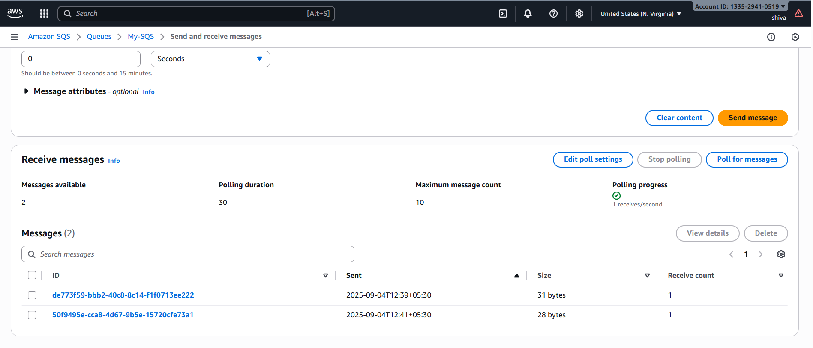

Step 4: Check Another Tab

1. Open the queue in another browser tab.  
2. Try Poll for messages immediately → You will NOT see the message.  
○ That’s because the first tab has a lock on it for 30 seconds.  
○ This lock is called Visibility Timeout.

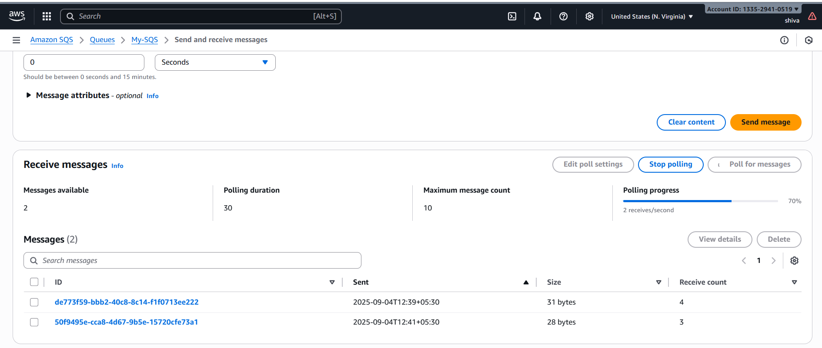

Step 5: Wait or Delete

● If you wait 30 seconds and then poll again → The message will reappear (since   
it wasn’t deleted).  
● If you delete the message from the first tab → It will be removed permanently   
and won’t show again.  
 ✅Key Learning:  
● Send → Poll → Delete is the full lifecycle.  
● If you don’t delete, the message keeps reappearing after timeout

MQ:

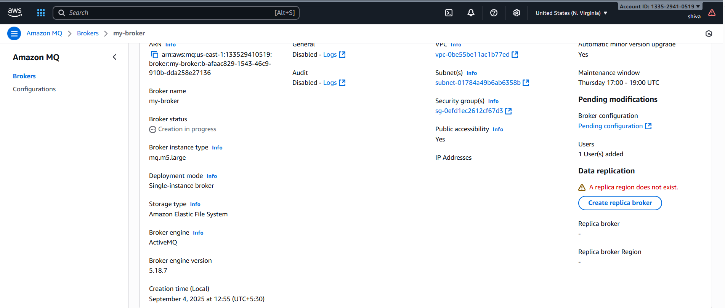

Copy Active MQ Web Console curl and open it

[https://b-afaac829-1543-46c9-910b-dda258e27136-1.mq.us-east-1.amazonaws.com:8162](https://b-afaac829-1543-46c9-910b-dda258e27136-1.mq.us-east-1.amazonaws.com:8162/)

